**TASK MANAGEMENT SYSTEM**

**Members:** Pavan Kalyan Mandapaneni, Vineetha Madasu, Sai Venkata Revanth Ashok Thokala

**Project Title:** Task Management System

**Project Description:**

The **Task Management System** is a web-based application designed to enhance productivity and streamline task management for individuals and teams. This system provides robust features for task organization, delegation, and monitoring, ensuring that users can efficiently manage their workflows. With a user-friendly interface and powerful functionality, the system caters to both personal and professional task management needs.

**Key objectives of the system include:**

* Simplifying task creation, assignment, and tracking.
* Enabling seamless collaboration among team members.
* Providing real-time updates and analytics for better decision-making.
* Integrating with tools like **Google Calendar** for enhanced scheduling and reminders.

**Project Scope**

|  |  |  |
| --- | --- | --- |
| **Task Management System** | | |
| User Management | Task List | Task Analytics and Reports |
| **C:** User Registration  **R:** UserProfile  **U:** Personal Info.  **D:** Account Deletion | **C:** Tasks, Titles, Dates,Category/Priority  **R:** Task Viewing  **U:** Task and Status  **D:** Task Deletion | **C:** Generate Reports On Completed Tasks and Pending Tasks.  **R:** View Graphical Chart  **U:** Customize Report  **D:** Delete Reports |
| Vineetha Madasu | Sai Venkata Revanth Ashok Thokala | Pavan Kalyan Mandapaneni |
| Google Calendar, MongoDB Database | | |

**USER Flow Diagram:**

The user flow diagram below illustrates the seamless navigation and interaction within the Task Management System:

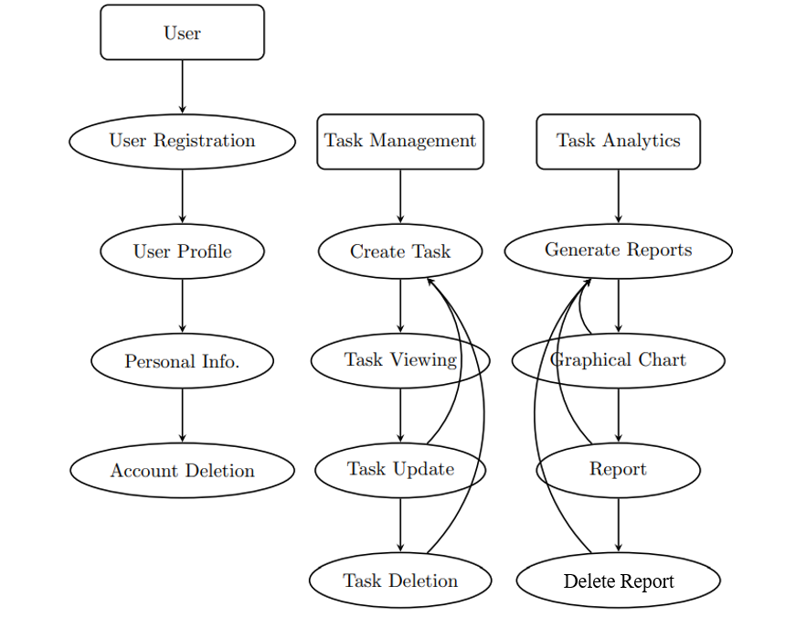

**Screenshot:**

**User Registration**The User Registration Page allows new users to create an account by entering essential details such as their name, email address, and password. This page ensures a secure and straightforward onboarding process, enabling users to quickly start using the system.

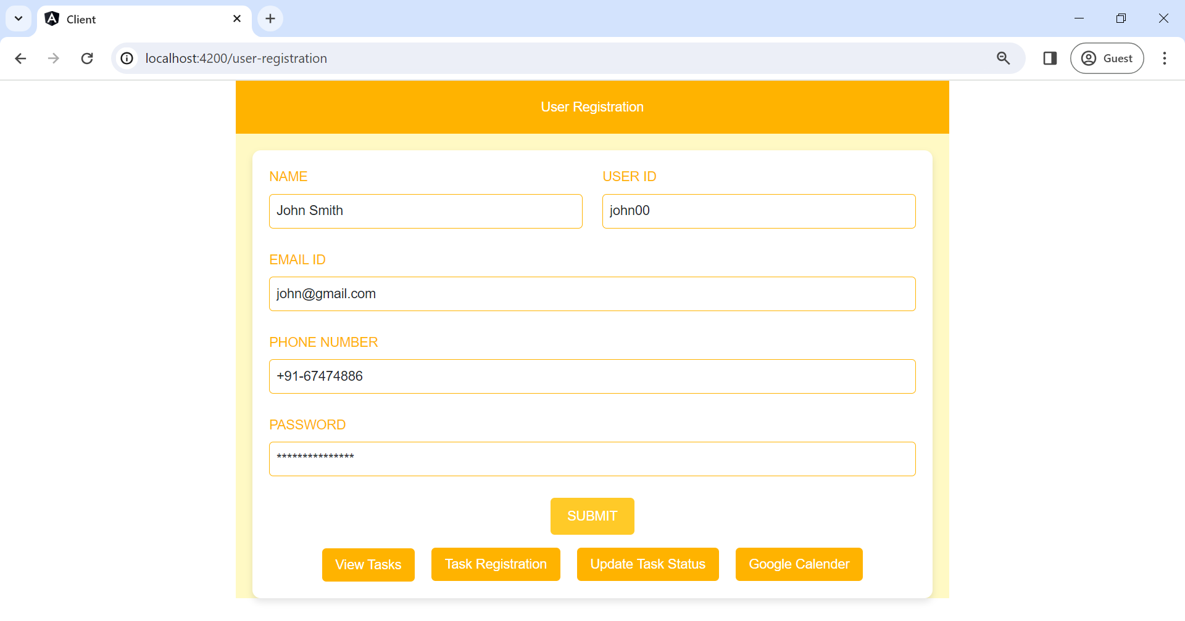

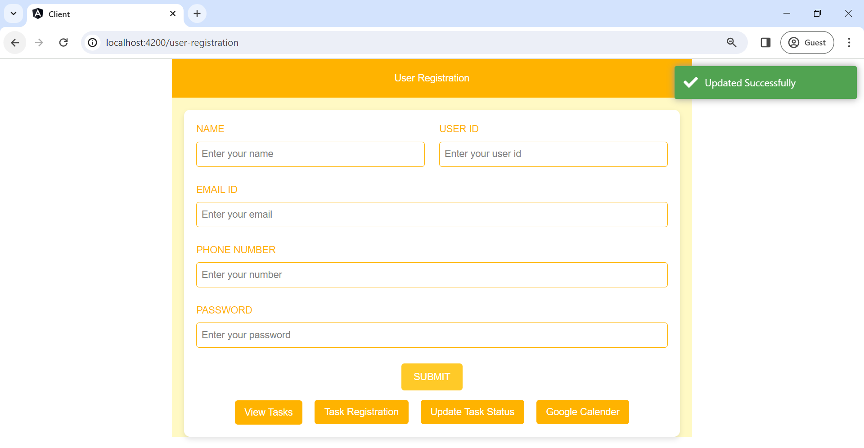

**Task Assignment:**The Task Creation Page enables users to create new tasks by specifying details such as the task title, description, due date, category, and priority level. This page is designed to be intuitive, allowing users to quickly add tasks without unnecessary complexity.

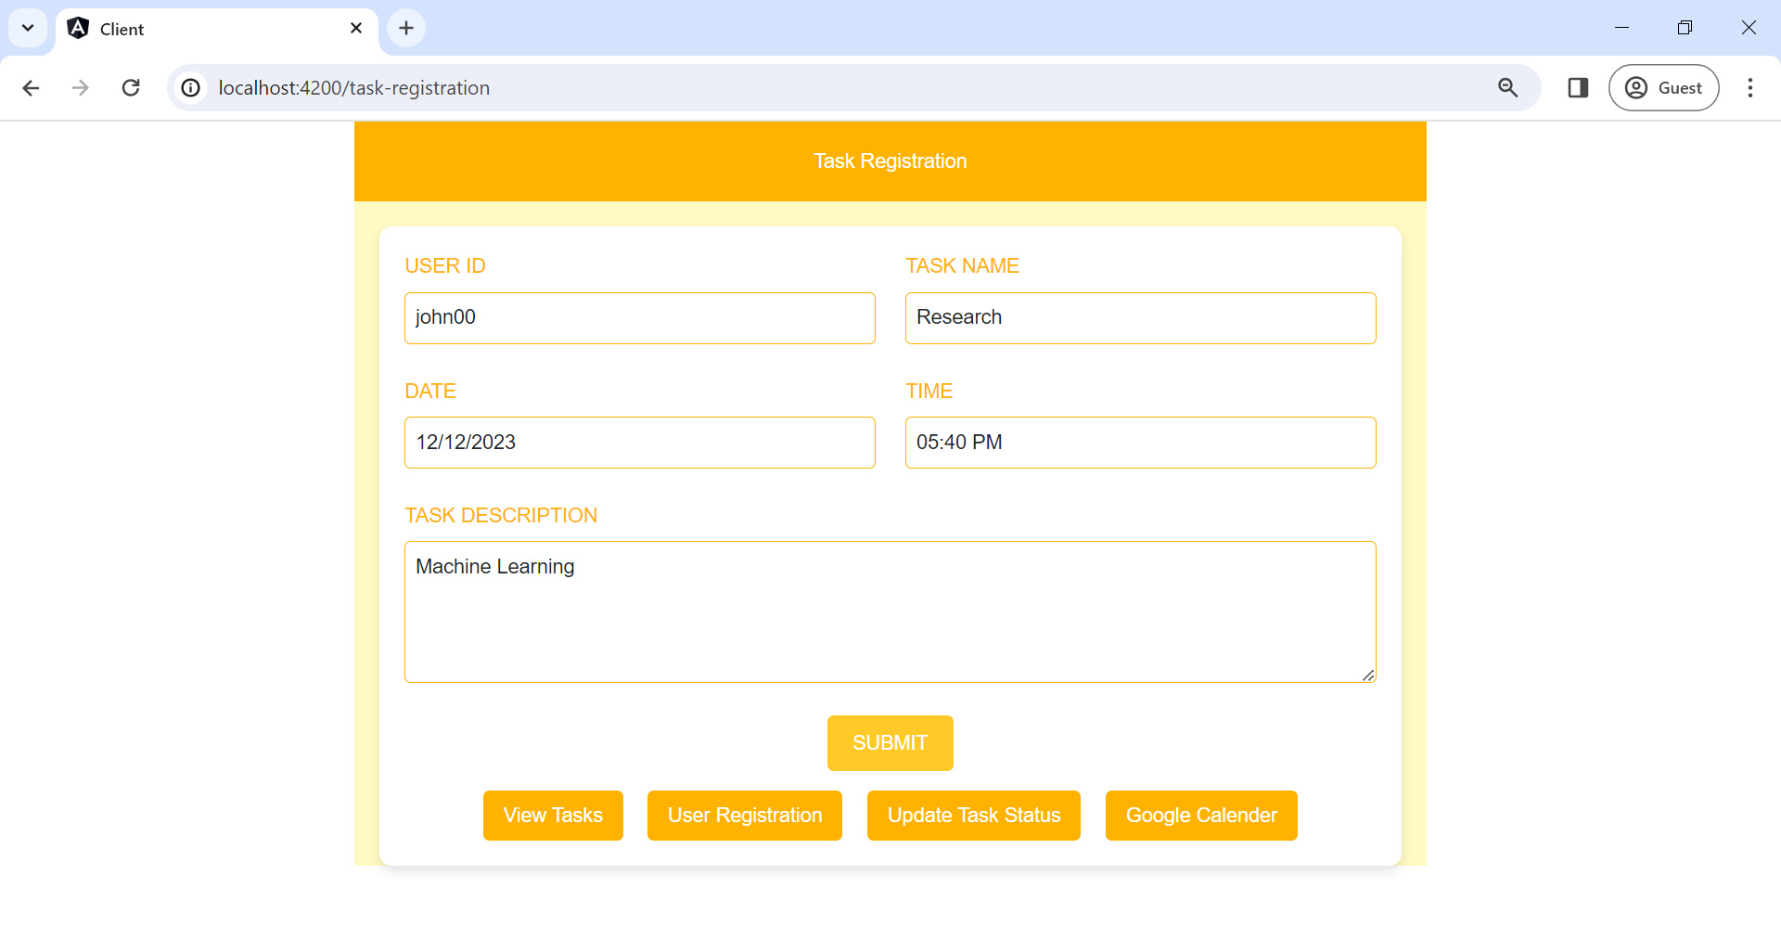

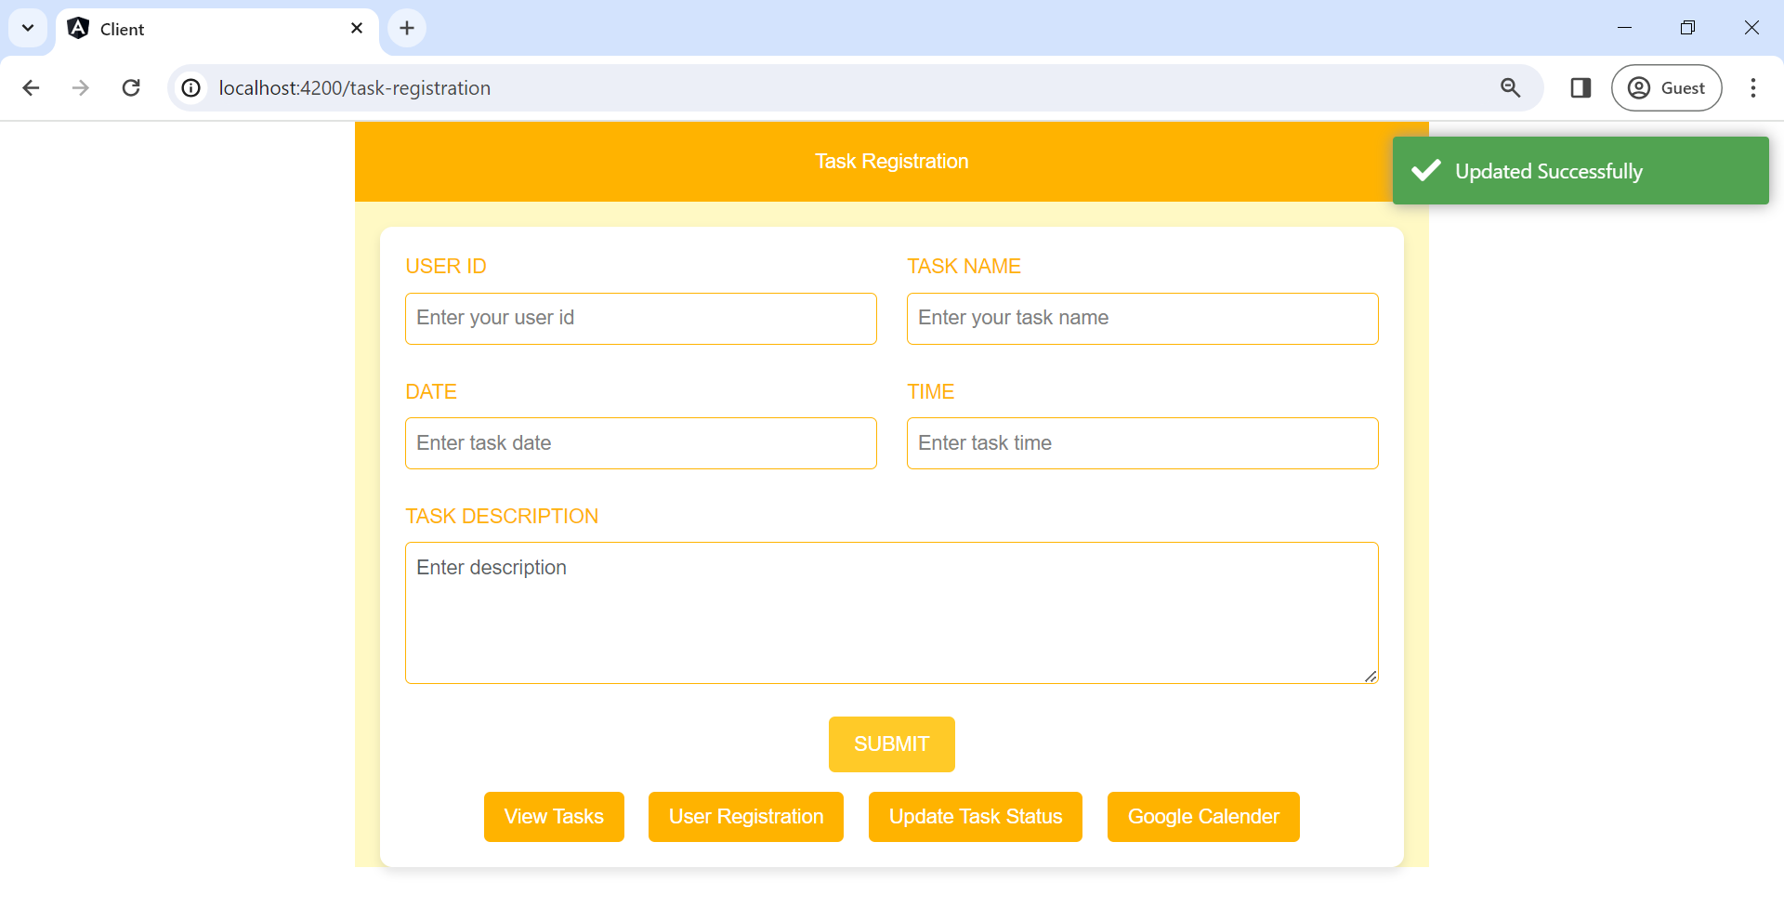

**Update Task Status**The Task Status Update Page provides users with the ability to update the status of tasks (e.g., "To Do," "In Progress," "Completed"). This feature ensures real-time tracking of task progress and helps teams stay aligned on project milestones.

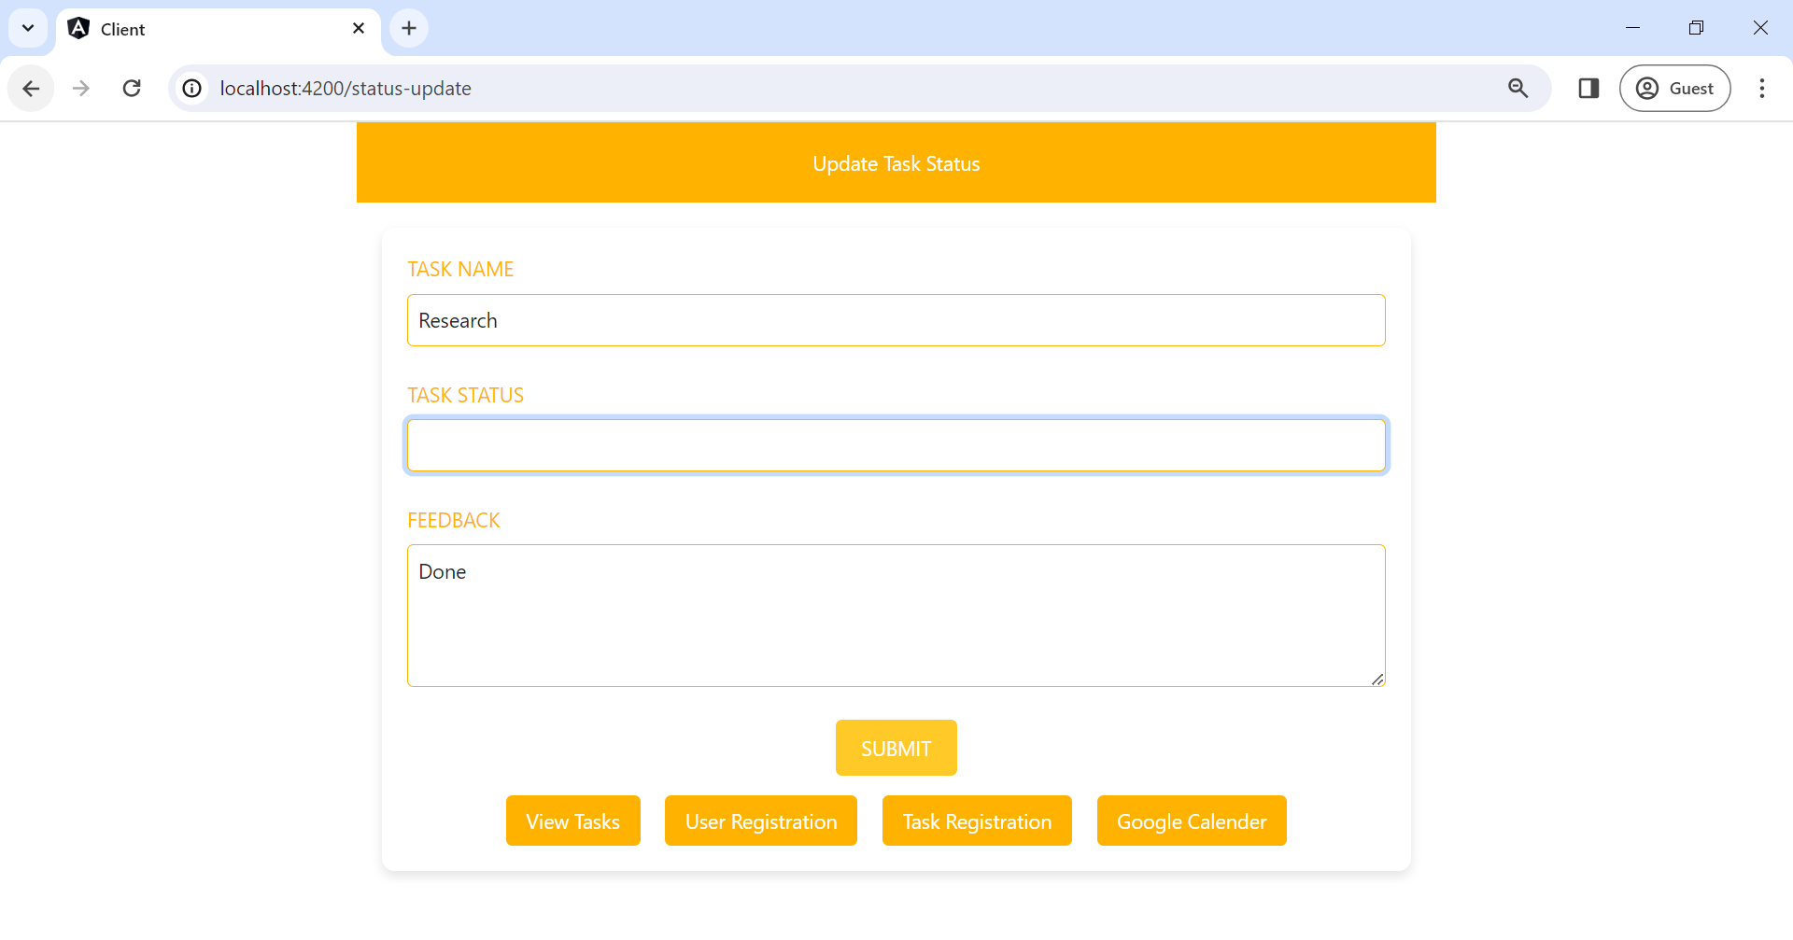

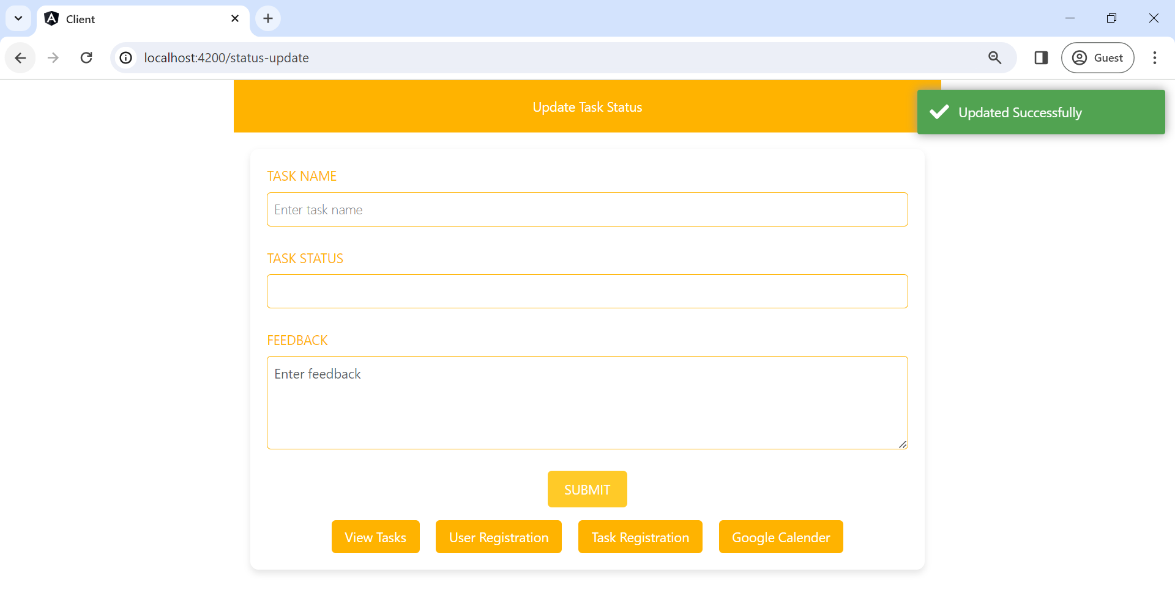

***Google Calendar API***The Google Calendar Integration feature syncs tasks with the user's Google Calendar, providing a unified view of deadlines and schedules. This integration ensures that users never miss important deadlines and can manage their time effectively.

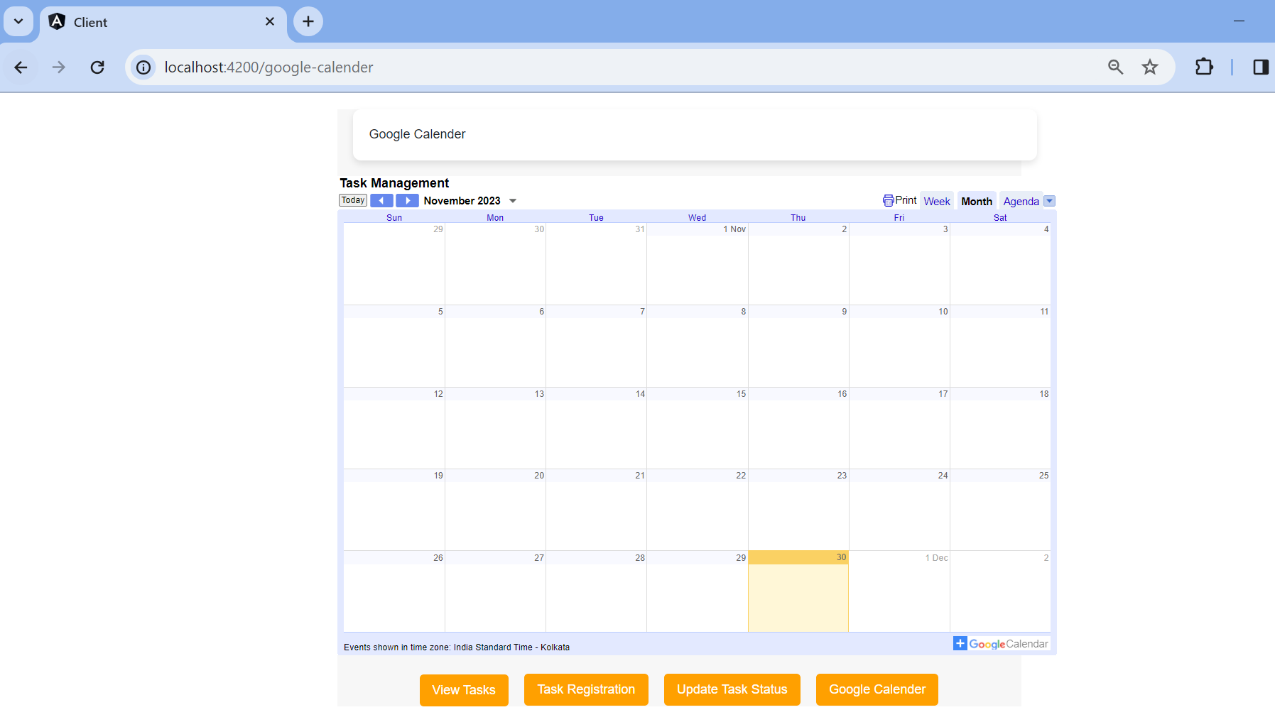

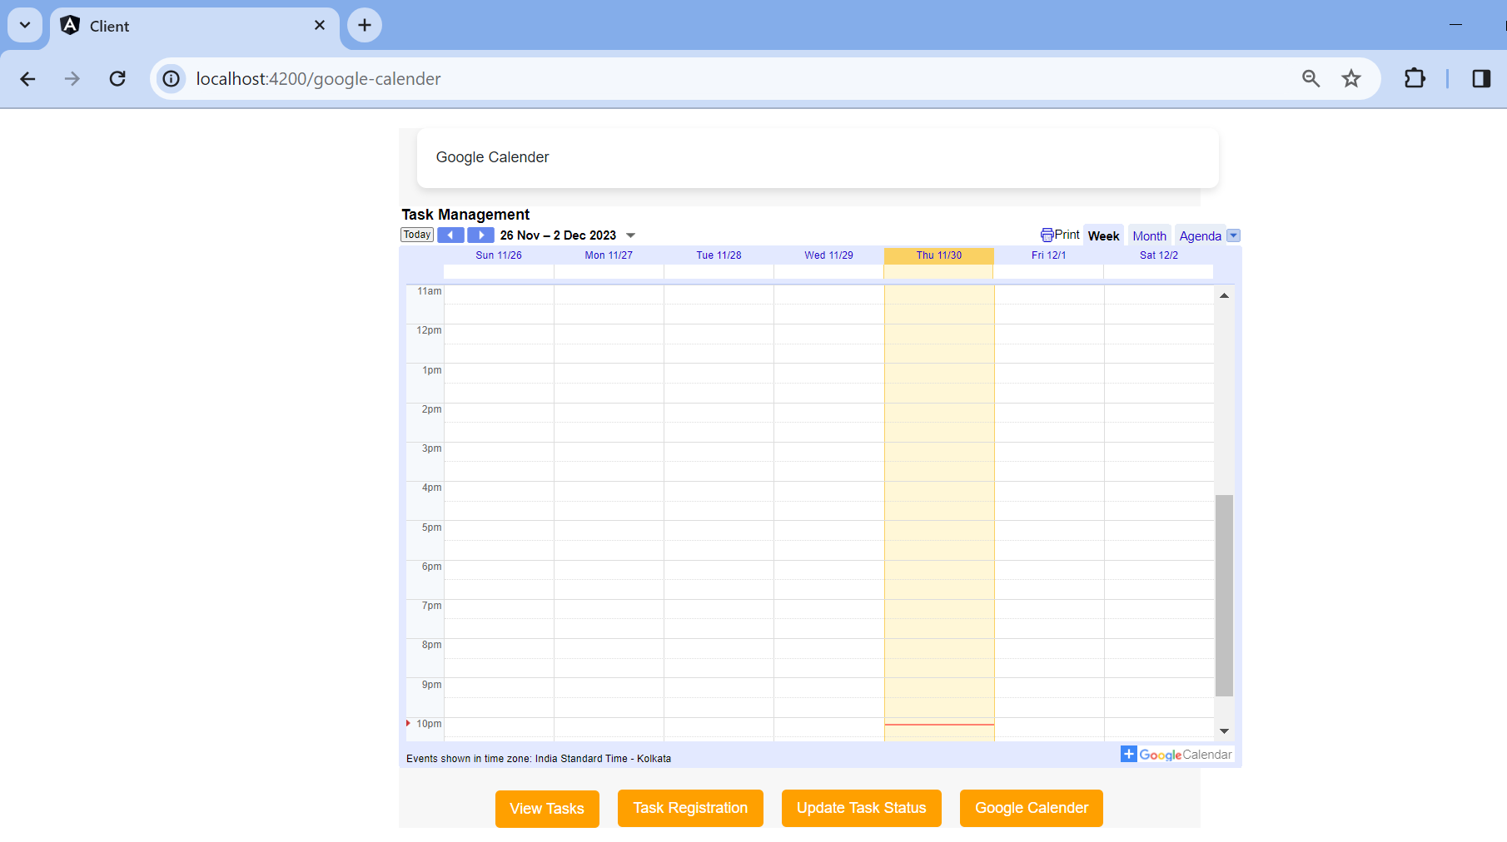

**Task Management**

The Task Management Dashboard provides an overview of all tasks, including pending, in-progress, and completed tasks. Users can quickly assess their workload and prioritize tasks based on deadlines and priorities.

